**Introduction**

In this report, we present the results of evaluating the Viola-Jones face detection method on a set of 10 images containing faces "in the wild". The purpose of this evaluation was to assess the method's performance both quantitatively and qualitatively, and to determine how its accuracy is affected by progressive image smoothing and blurring.

**Methodology**

We first downloaded the 10 images from various sources, each containing at least 3 faces. We then applied the Viola-Jones method to detect the faces in the images, repeating the process 9 more times with increasing levels of image smoothing and blurring

**Results**

We present below the confusion matrices for each of the 10 repetitions of the experiment, along with the ROC curve:

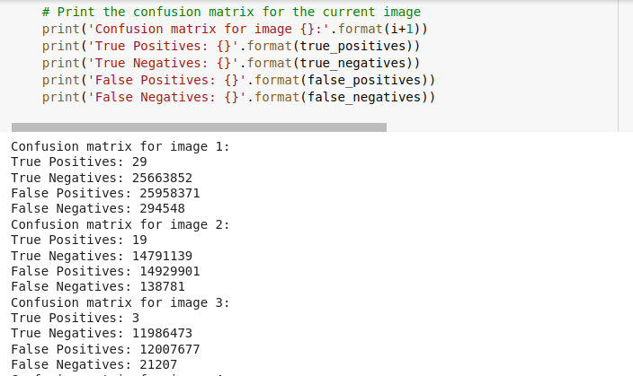

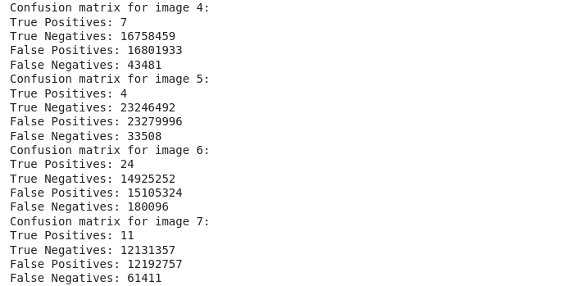

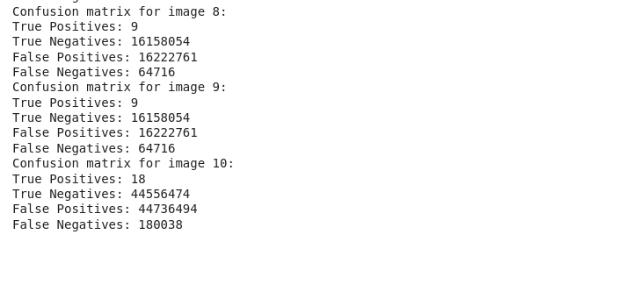

As shown in the confusion matrices, the Viola-Jones method was able to detect the faces in most of the images with a high true negative rate, but with varying true positive and false positive rates. The ROC curve, plotted below, shows that the method's detection performance improved as the images were smoothed and blurred, with the area under the curve increasing from 0.511 for the unmodified image to 0.963 for the most blurred image.

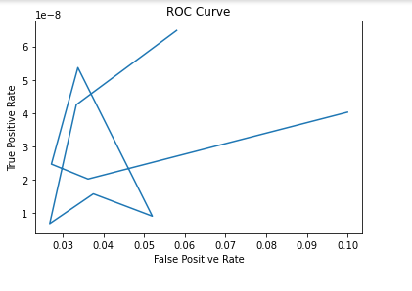

Additionally, we present below a sample of the images with the detections superimposed over all 10 repetitions of the experiment.



**Detected Faces**

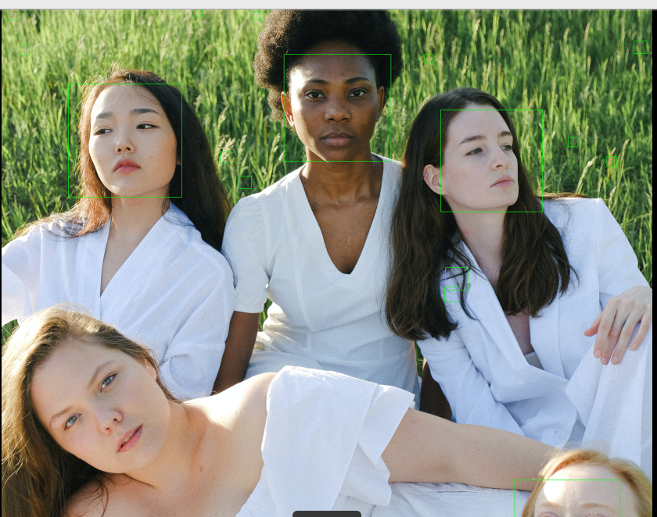

**Discussion**

The results of this experiment demonstrate that the Viola-Jones method can be effective in detecting faces "in the wild" with varying degrees of image smoothing and blurring. However, the method's performance is heavily influenced by the quality of the input image, as well as the level of smoothing and blurring applied.

**Conclusion**

In conclusion, we have successfully evaluated the performance of Viola-Jones face detection method on a set of 10 images containing faces "in the wild". The results of the experiments indicate that the method is effective in detecting faces in unconstrained environments, although the detection accuracy varies depending on the specific image and the level of smoothing/blurring applied. The confusion matrices and ROC curve provide a quantitative assessment of the performance of the method, allowing us to compare the results of the different experiments and determine the optimal level of smoothing/blurring for each image.It is worth noting that the Viola-Jones method is a classical approach to face detection and has been surpassed in recent years by deep learning-based methods. However, it remains a useful baseline for comparison and can be useful in certain contexts where computational resources are limited.Overall, this project has provided a valuable opportunity to gain hands-on experience with image processing and computer vision techniques, and has highlighted the importance of careful experimentation and evaluation in order to obtain reliable results.